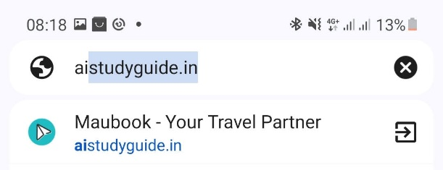

When you search maubook, it indicates travel partner, it is not a travel partner. Kindly change



I dont find this to be attractive. Its too compact and together and to small to visualise. Need to rework. I have send you the sample on whatsapp

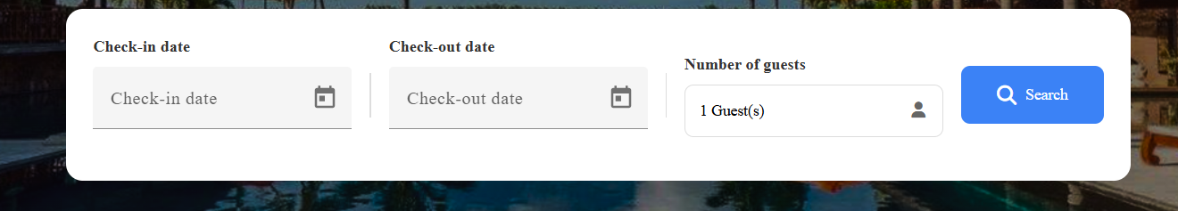

This has to be more vibrant and a bit colourful. Can we have an outline of the blue coulour of maubook. And the search button . make it same coulour of maubook , it does not match the main blue

3. 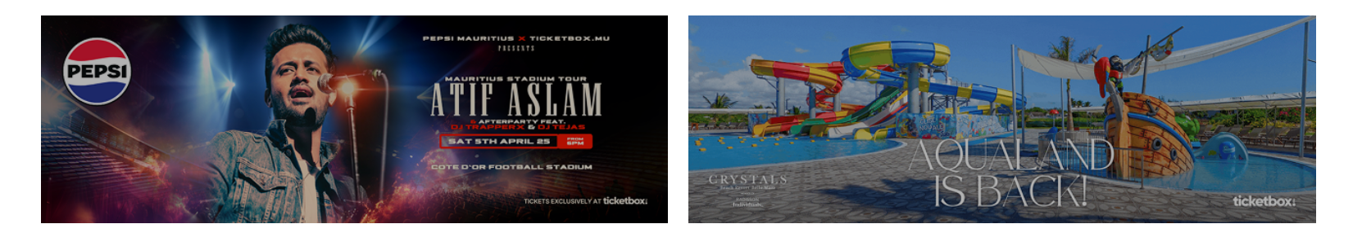

This should be clickable photos, when you click, it should redirect you to the event or hotel

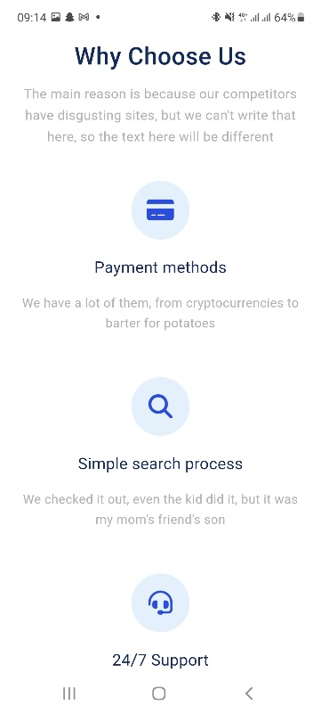

This is too long on the website, its on mobile version, can we put horizontal and have a slider

Example : 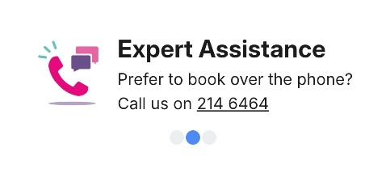

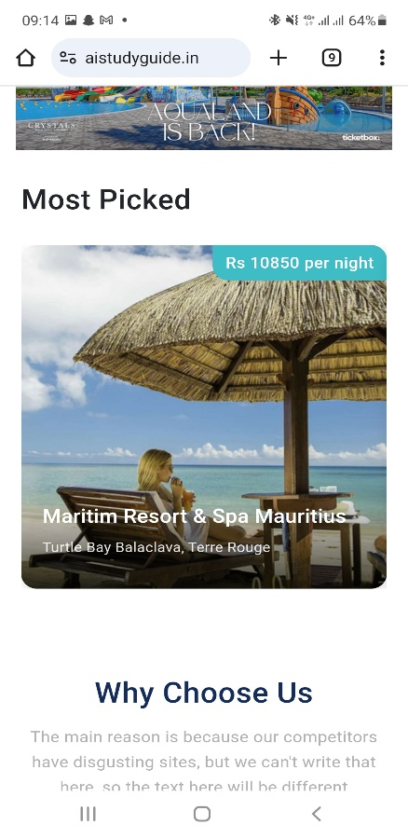

This is the mobile version of most picked, people dont know if we have to slide to get others offer, put slider same as examples or arrows

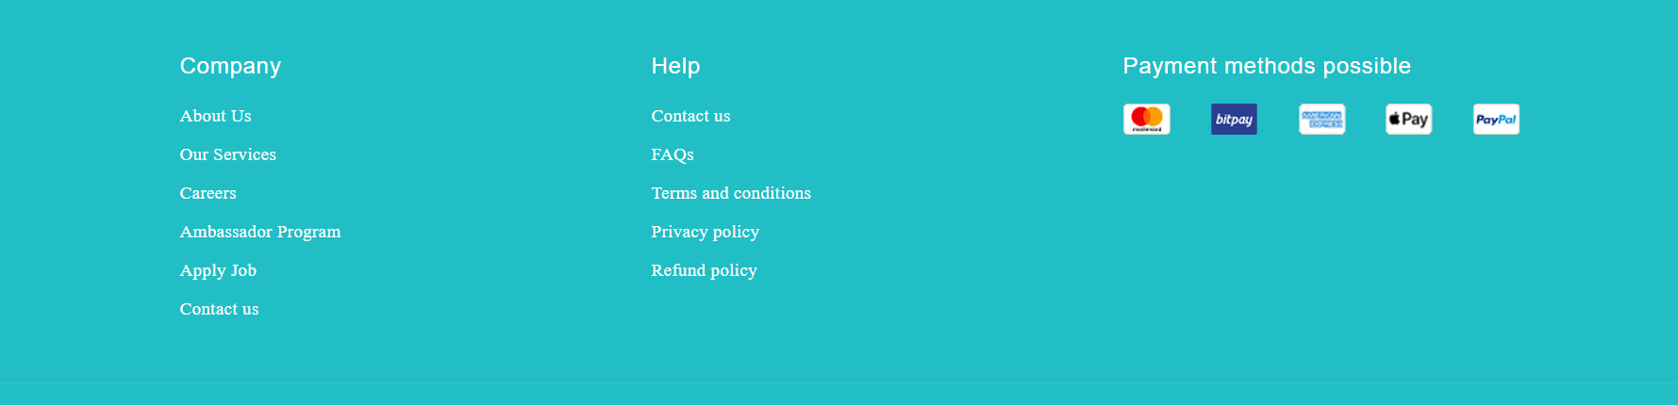

**Here remove careers, ambassador program, apply job**